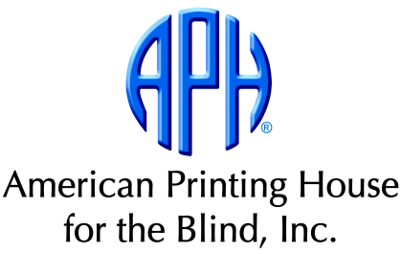
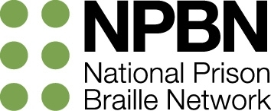

Braille Transcriber Apprentice Program (BTAP)
FY2015 Pilot Program

Eligibility Criteria and Application Process

Thank you for your interest in the Braille Transcriber Apprentice Program's FY2015 Pilot Program, which will operate from October 1, 2014 through September 30, 2015. To be considered for this apprentice program, please review the Eligibility Criteria below carefully. If you meet these criteria, determine which application category applies to you (Current or Future) and follow the application directions.

BTAP Eligibility Criteria

To qualify for this model reentry program, applicants must have...
- Participated in a prison braille program that is affiliated with the National Prison Braille Network. (Membership is free and open to all programs.)
- Earned Literary Braille Certification through the NLS (National Library Services for the Blind and Physically Handicapped, Library of Congress).
- Preferably earned at least one advanced certification: Textbook Formatting, Literary Braille Proofreading, Nemeth Braille, Nemeth Braille Proofreading, or Music.
- Preferably gained tactile graphics design and production experience.
- A commitment to pursuing a career in braille transcription.
- Motivation to learn all aspects of accessible media production, including electronic file manipulation.

Ideally, offenders still working in prison braille programs with between six months and one year remaining before parole or serve-out will be selected for the program. This will allow time to help participants make a smooth transition to APH. APH staff will work with inmate case workers and parole officers during this time to ensure that release requirements (if any) are fulfilled. Transcribers who meet other program criteria and have already been released from prison will also be considered. Sex offenders will not be eligible to participate in the BTAP pilot initiative.

BTAP Application Process

APH is currently accepting applications in two categories: Current and Future.

Current Applicants

These individuals have either already been released from prison, or have less than one year remaining before their next parole board meeting or serve out date. They must send to APH a completed Application Form, along with all attachments requested below:
- A personal letter or essay explaining why you are applying for BTAP. Include:
- a description of your experience in the prison braille program,
- what braille means to you,
- your career goals,
- challenges you face to achieving these goals following release, and
- resources available to you upon release to complete your goals.
- A resume or list of your transcription work in the braille program.
- A copy of each braille certificate received.
- 3-5 samples of tactile graphics produced from masters that you created independently (if you produce tactile graphics).
- 5-10 pages of braille transcription work you produced independently, along with print copies of these pages.
- At least two (but no more than five) letters of recommendation, one of which must be from a corrections professional (preferably the braille program manager) who can speak about your conduct during incarceration and your tenure in the braille program. If you have worked with a vision professional who can attest to your braille production experience and transcription quality, a letter from this individual would be helpful.

People writing letters of recommendations can send them to APH separately from the application if they prefer. They should include the full name of the Current Applicant, and send letters to Nancy Lacewell at the address below.

Current Applicants will not be considered for BTAP until their entire application packet has been received (completed Application Form, and all requested attachments). APH will contact Current Applicants within one month of receiving their completed packet to discuss their individual status as a BTAP candidate.

Future Applicants

These individuals are currently working in prison braille programs and hope to be considered for the BTAP program in the future, if it is funded beyond the pilot year (FY2015). They have more than one year remaining before their next parole board meeting or serve out date. Future Applicants should send to APH a completed Application Form, but they do not need to send along the attachments requested for Current Applicants. However, these transcribers are encouraged to begin developing their application packet.

APH will contact Future Applicants within one month of receiving their application to confirm receipt.

*********************************************************

All applications and packets should be mailed to:
Nancy Lacewell
BTAP Application
American Printing House for the Blind
1839 Frankfort Avenue
Louisville, KY 40206

*********************************************************

Questions should be directed to a member of the BTAP Implementation Team:
Nancy Lacewell, BTAP Coordinator
Phone: 502-899-2339; or 800-223-1839 ext. 339
Email: nlacewell@aph.org
Becky Snider, BTAP Administrator
Phone: 502-899-2356; or 800-223-1839 ext. 356
Email: rsnider@aph.org
Jayma Hawkins, BTAP Apprentice Mentor
Phone: 502-899-2372; or 800-223-1839 ext. 372
Email: jhawkins@aph.org

