Beginning coding lesson plan
Robbin Clark, MA

Learning objective:
- Students will identify the purpose/function of coding. They will demonstrate understanding of coding principles by defining & providing an example of algorithms, sequence and loop.
- Students will apply principles of coding to everyday tasks such as making a peanut butter & jelly sandwich.

Discussion question: what do you think it means “to write code” or “coding”?

- Coding is the method of giving instructions to a computer to perform a specific task. You may have also heard it referred to as “software programming” or “computer programming.”
- These instructions are communicated using a “computer language” that computers can understand.
- These languages include visual blocks, Java, Python, and C. Learning to code expands problem solving and critical thinking skills, making it a great opportunity for kids to build those skills while young.
Source: https://www.tynker.com/coding-for-kids/what-is-coding-for-kids

Enduring understanding: the five steps of the problem solving method can help with analyzing problems.
Problem solving cycle:
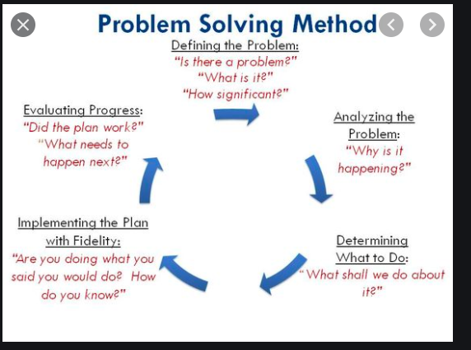

Coding concepts:
Source: https://teachyourkidscode.com/coding-for-kindergarten-5-basic-coding-concepts-5-year-olds-can-understand/

Algorithm: An algorithm is an instruction given in order to complete a certain task and receive the desired result. So, a computer programmer will write an algorithm to tell the computer how to perform a certain task to produce that result.

Think of an algorithm as a recipe. It state specifically what to do in a sequence

Sequence: Sequence is basically completing a task in a certain order.

Loop or Repeat: In coding, loops allow you to repeat something again and again. Loops will repeat until you give instructions for the computer to stop. In some cases, you might tell your computer to stop after it has repeated the loop a certain number of times. In other cases, you may tell your computer to stop once a certain condition is met.

Assessment:
- Ask students to use their own words for the coding concept principles.
- Give examples of specific and general directions.
  - Ask students to identify both and provide examples of each.

Activity: Write a program for making a peanut butter & jelly sandwich
Command ideas:
- Use a plate
- Take out two slices of bread
- Use a spoon
- Spread the peanut butter
- Spread the jelly

Activity: brush your teeth
Command ideas:
- Wet toothbrush
- Measure toothpaste
- Put on toothbrush

Activity: wash your hands
Command ideas:
- Turn on water
- Pump soap
- Scrub hands (insert a loop!)

Use the coding cards: http://adifferentkindofvision.blogspot.com/2019/04/teach-coding-with-expanded-core.html

